TY B.Tech. (CSE) – II [2022-23]
5CS372: Advanced Database System Lab.
Assignment No. 2
Name : Tanaya Mukund Bhide
PRN : 2020BTECS00011
Batch : T5
Branch: T.Y CSE
Installation, configuration & testing of Oracle 12c EE / 18c XE
Installing Oracle 18c XE:
1)Download the Oracle 18c XE file from oracle website for your OS. Extract the zip file and open the setup.exe file.

Downloading the zip file

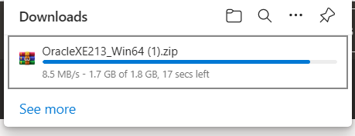
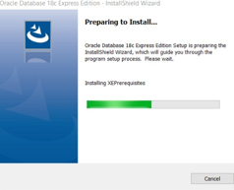

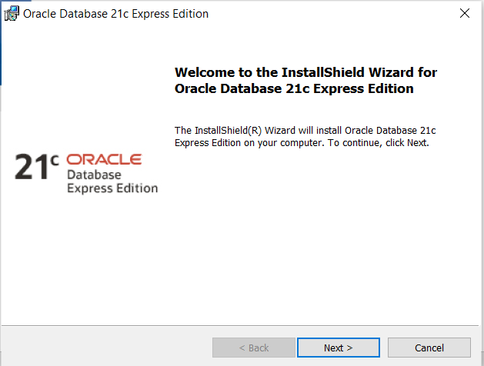

2)Read & accept the License Agreement.

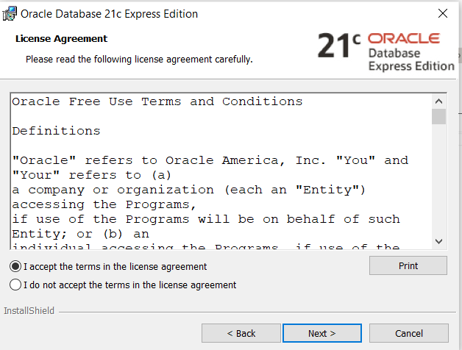

3)Choose the destination to install the Oracle 18c Database.
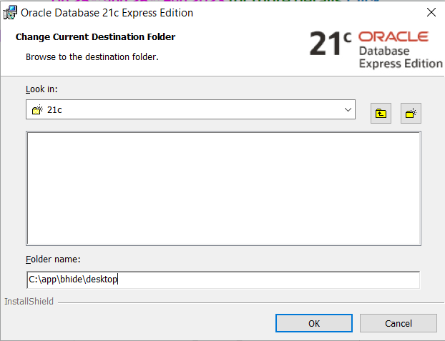

4)Enter the password for the database.
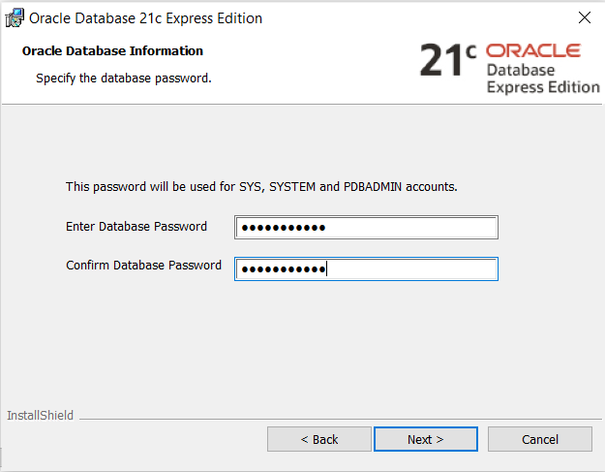

5)Verify the selected parameters.
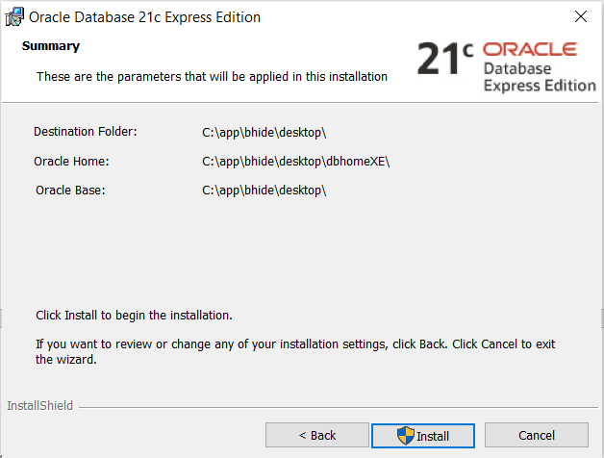

6)Wait for installation to be completed.
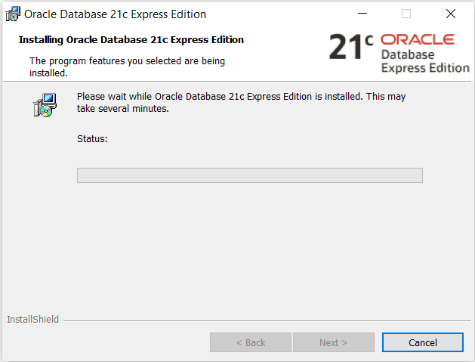

7)When the installation is completed, note down the connection information.

8)Hence, the Oracle Server (18c Express Edition) is installed successfully.

Connectivity:
Connecting as system:

Installing MySQL:
1)Install the setup for MySQL from MySQL website. Run the setup.exe. Choose installation type as ‘Full’.

2) Click execute to install the required setups.

3) Wait until all the files are installed.

4) Configure the product by clicking next.

5) Configure the network and click next.

6) Set the password for ‘root’ (admin) and click next.

7)Configure the windows service to start. Click next.

8)Connect to server by logging in with the created credentials. Check the connectivity.

9)Apply the configuration by clicking on execute. Wait for all changes to be applied. MySQL is installed successfully.

